**Computer Vision System to Identify Boxes in an Image**

**(or some similar nonsense)**

Rachel Mertz Matthew Varas

Affiliation: St. Cloud State University Affiliation: St. Cloud State University

mera0902@stcloudstate.edu vama1304@stcloudstate.edu

**ABSTRACT**

Type abstract here.

1. **INTRODUCTION**

Paragraph 1: discuss …

Paragraph 2: discuss …

1. **THE PROBLEM**

Paragraph 1: discuss …

1. **PROCESSING STEPS**

The vision program begins by applying the preprocessing step of averaging, in an attempt to reduce the sheer volume of information in the image. Averaging accomplishes this reduction by taking a block of pixels in the original image, averaging all values of the pixels in that block, and storing this averaged value in one pixel of a new image. The resulting image is smaller, ideally with minimal loss of information.

The figures below show three sets of images, both the original image and an averaged version.

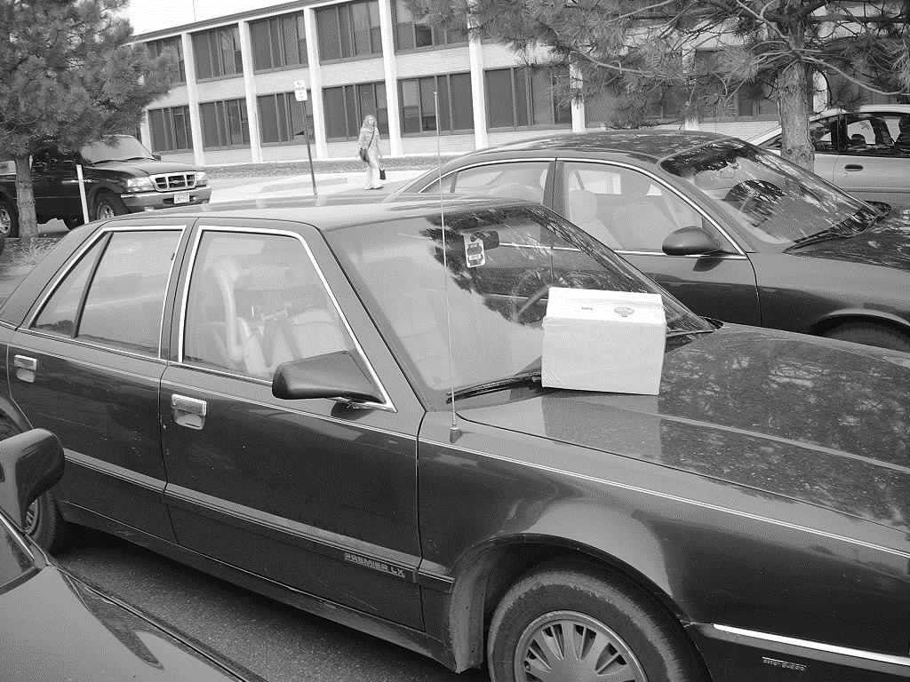

**Figure 1:** Original

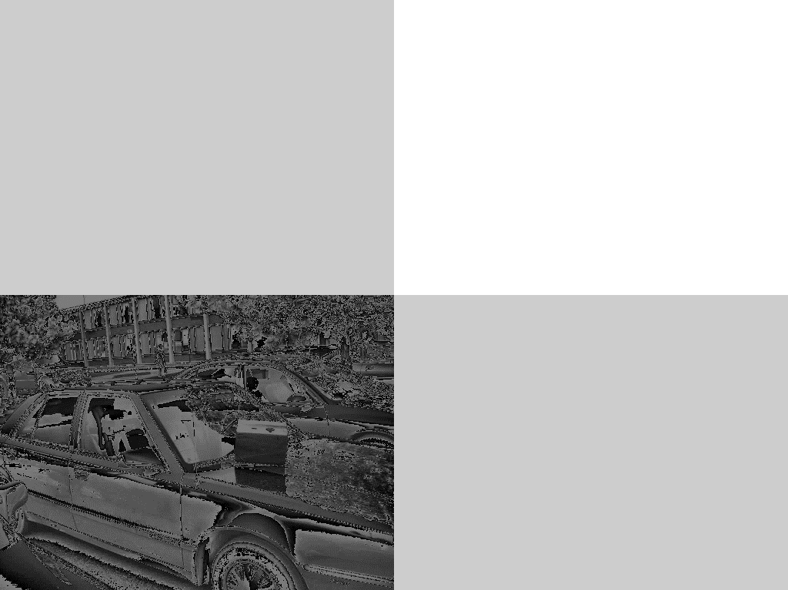

**Figure 2:** Averaged image

Figure 2 shows an image averaged in blocks of 4 pixels. This ratio yields a fairly recognizable version of the original image, and it can be seen that the pixel values on the different faces of the box are virtually uniform. The box’s edges are now clearer, making it easier for an edge-detection algorithm to identify edge elements, and in turn, find the whole box.

1. **IMPLEMENTATION**

Implementation of box identification was not accomplished in this program, but we believe that averaging and judicious use of other preprocessing techniques will lay the foundation for implementing an algorithm to successfully identify a box. In particular, steps to extend the program might include applying histogram equalization and sharpening to finish the image preprocessing steps, then implementing a combination of Stefanelli and Rosenfeld’s thinning algorithm and the Hough transform to successfully identify boxes in multiples images.

1. **PERFORMANCE – seems like this could go away since it’s talking about performance wrt box finding**

Paragraph 1: discuss …

1. **DISCUSSION**

Paragraph 1: discuss …

1. **CONCLUSION**

Paragraph 1: discuss …

.